**CAD Solid and Field**

User Manual

**The Software prepared by**

Miljan Milošević

Vladimir Simić

Bogdan Milićević

Miloš Kojić

September 2022

Contents

Acknowlegment 3

About CAD 3

1 General structure of CAD GUI 3

1.1 Title bar 4

1.2 Main menu 4

1.3. Workspace 13

1.4 Common menu bar 13

2 PAKSF module 14

3 PAKT module 30

4 PAKFIS module 31

5 PAKSF2D module 31

6 PAKSF3D module 32

7 Composite2D module 33

8 Composite3D module 33

9 Partitioning module 34

10 PAKC module 35

11 Nanofibers module 38

12 Nanofibers smeared module 39

13 Cell Tissue module 40

14 Param Space module 40

15 Metastatic Tumor module 41

## Acknowlegment

We here acknowledge the researchers and people who give significant contribution to a C++ library of the code which serve as a basis for the CAD Solid and Field software.

Boban Stojanovic, Nikola Milivojević, Nenad Filipović, Vladimir Ranković, Lazar Otašević, Mileta Nedeljković, Velibor Isailović, Dejan Petrović, Žarko Milošević, Dalibor Nikolic.

## About CAD

The software relies on the work of the authors and contributors over more than twenty years. The core of the software was used as a basis for generation of different tools: <http://www.bioirc.ac.rs/index.php/software> (SOFTDISKUS, SOFTKARDIO, SOFTEHO, CFDAL, MedCFD, Lizza-PAKP) (Filipovic et al., 2005, Filipovic et al., 2006, Filipovic et al., 2010). All of this software is available free to download from the BioIRC website. The workflow diagram of the CAD Solid and Field software accompanying the book is shown in Fig.1.

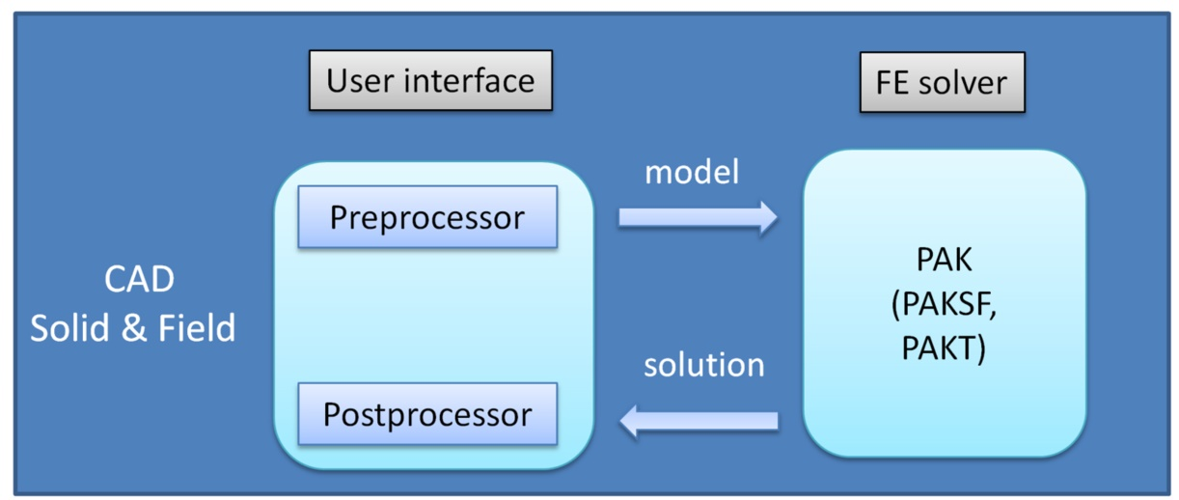

Fig. 1 Workflow diagram of the software accompanying the book.

CAD Solid and Field is the University of Kragujevac and BioIRC’s in-house pre- and post- processing 3D modeling and visualization tool developed using the MFC (Microsoft Foundation Class) library. CAD is integrated with PAK simulation code, it simplifies model generation and can visualize and animate results of computational simulations. As already notified, CAD has two modules: preprocessor and postprocessor. The preprocessor is used for model generation in a form that can be run using the FE simulation code. The creation of the model usually consists of geometry and mesh generation, adding constraints, loads, and materials. The model data are exported to a file with extension *.dat which is run by the FE solver PAK. The results of an FE simulation (field of displacement, velocities, pressures, concentrations, etc.) are exported to a file with extension *.unv that is automatically loaded by the postprocessor of the CAD. Therefore, the postprocessor is used for importing the results, and then it is used for visualization of the results and analysis by plotting various representations (field vs. time, field vs. distance, etc.). Various libraries are integrated into CAD, such as Triangle 2D mesh generator (Shewchuk, 1996, Shewchuk, 2002), TetGen 3D mesh generator (Si, 2015), as well as Libigl library (Jacobson et al., 2018).

Software is developed using Visual Studio 2017 and is intended to be used on Windows OS. Software is available in x32 and x64 versions. Requirements: Microsoft C++ Redistributables 2017. To plot diagrams the requirement is MsChart (mschrt20.ocx) control to be registered for the win32 version of CAD. Explanation of how to register and use MSChart control is given within the GitHub link.

## 1 General structure of CAD GUI

The user interface of the CAD-Field and Solid software consists of several main components providing information and tools for model design and displayed in the subsequent figures. The components are:

• Title bar

• Main menu

• Workspace

• Common menu bar

• Module menu bar

• Status bar

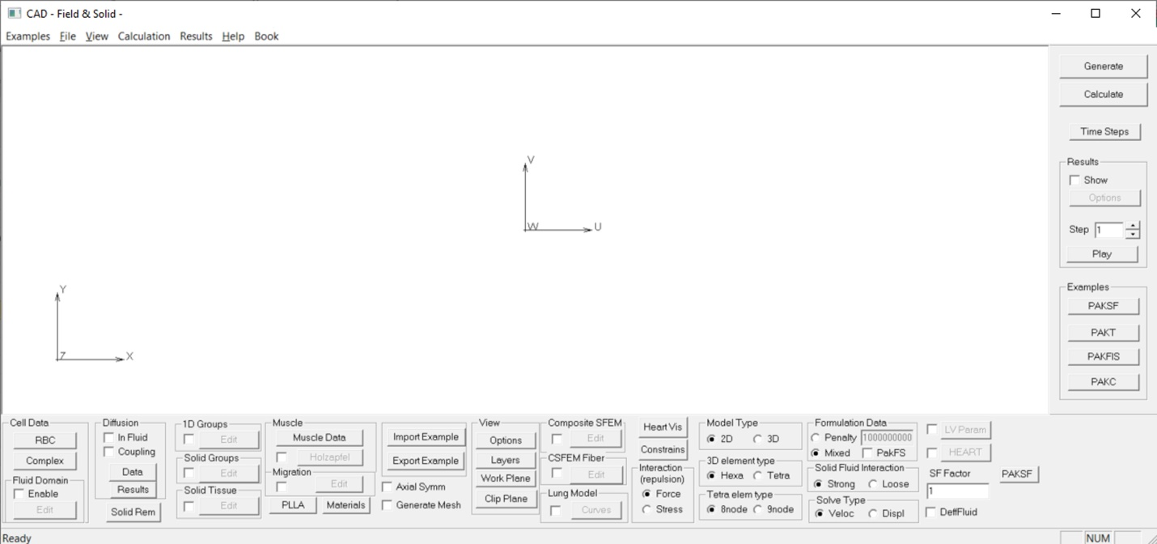

Fig. 1.1 CAD Solid and Field user interface software

### 1.1 Title bar

The Title bar is the line at the top of the window, Fig. 1.2. Standard Windows buttons Minimize, Maximize, and Close are placed on the right side of the Title bar.



Fig. 1.2 Title bar

### 1.2 Main menu

The Main menu is positioned under the Title bar and provides several submenus:

* Examples
* File
* View
* Calculation
* Results
* Help
* Book

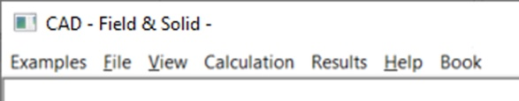

Fig. 1.3 Main menu of the CAD Field & Solid user interface software

#### Examples - Description of software modules

During the years, we developed several user interface software which helped in the pre- and post- processing of results of numerical simulations for all research we conducted, and some of them are collected in this book. To group all this software we integrated all those separate applications in this one which is available for the readers of the book. As it can be seen from Fig. 1.4, the menu item Example consists of various modules.

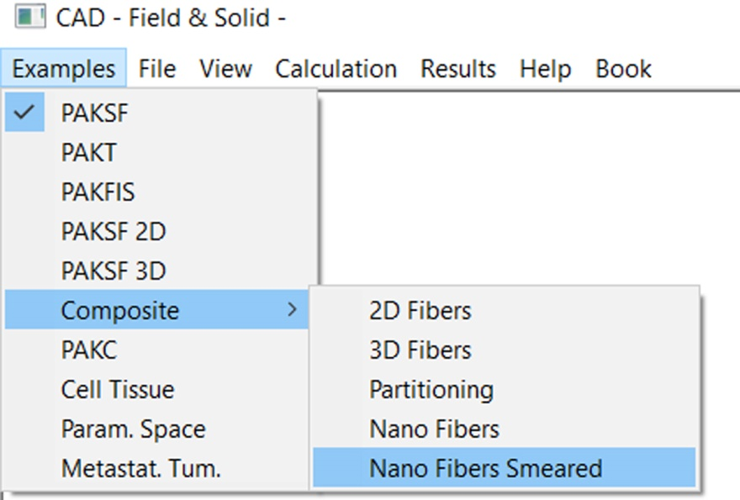

Fig. 1.4 Example menu - software modules within CAD interface software

Examples covered in this book are generated using some of these modules:

1) PAKSF (PAK for Solid and Fluid) – Module for generation of various solid mechanics, fluid mechanics, and solid-fluid interaction problems, and also for CSFEM model for smeared solid mechanics.

2) PAKT (PAK for heat conduction, diffusion, and electrophysiology transport) – Module for generation of various heat conduction and diffusion transport models, such as the drug transport in an organ and tissue with cells, coupled convective-diffusive transport in organs with a capillary network, application of the KTM model, electrical transport in tissue and specifically in heart tissue, transport of immune cells and also modeling of drug delivery in a human eye model.

3) PAFIS (PAK for Field and Solid) – module for solid-fluid interaction problems coupled to the drug transport, heat conduction, and electric transport.

4) PAKSF 2D (PAK for solid-fluid interaction in 2D) - module for 3D solid-fluid interaction problems, for a deformable particle transport within a fluid.

5) PAKSF 3D (PAK for solid-fluid interaction in 3D) – module for 3D solid-fluid interaction problems, for a deformable particle transport within a fluid

6) Composite – consists of five modules for modeling diffusion transport problems in nanoconfined space:

* 2D fibers – 2D composite models with nanofibers in a nano-confined space
* 3D fibers – 3D composite models with nanofibers in a nano-confined space
* Partitioning – Module for investigation of hydrophobicity effects on a drug transport between different media.
* Nano fibers – investigation of drug transport from nanofibers – the detailed model
* Nano fibers smeared – investigation of drug transport from nanofibers – the smeared (KTM) model

7) PAKC – module for modeling stents and in-silico simulation of standard ISO test for optimization of new stent designs (not available for the book).

8) Cell Tissue – Drug transport within tissue with cells, capillaries and lymph system, using PAKT.

9) Param. Space – Parametric space module for spherical tumor embedded in pancreatic tissue, using PAKT.

10) Metastat. Tum. – Special module designed for perfusion within liver containing a small metastatic tumor, using PAKT.

#### File

Submenu File is used to import *.unv (UNV)files from earlier runs of this software, or to export *.dat (DAT) file created by this interface, Fig. 1.5. As already mentioned, UNV files are used to store the results of a FE simulation and can be read by CAD. File with extension *.dat is an input file for the FE simulation code PAK and is used to store the model data such as FE mesh, boundary conditions, prescribed values, etc. Additionally, using Export > BMP file…, it is possible to export a snapshot of workspace to a bitmap file, or using Export > Avi file… it is possible to export simulation sequence as a video file. Using the New button the current module can be reset while using the Exit button the application can be closed.

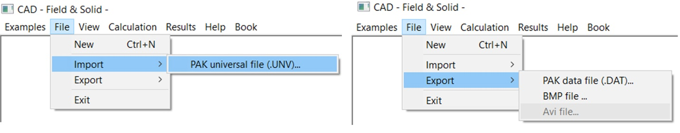

Fig. 1.5 Submenu File is mostly used for import of results of a FE simulation from *.unv file, or for export of *.dat file for FE simulation, and BMP and AVI file as a result of a FE simulation

#### View

Submenu View provides a selection of view options, Fig. 1.6. Using these options the model can be zoomed, or you can change the viewpoint, toggle between wireframe and shaded model, enable drawing of various model components, and set other drawing options. Use hotkeys shown next to the option name to accelerate view options.

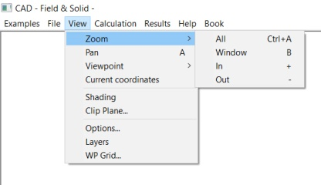

Fig. 1.6 Submenu View provides a selection of view options

##### Zoom

* **All** Ctrl+A
* **Window** B
* **In** +
* **Out** -

Zoom options are used to reduce or magnify the view of a drawing. The view of a drawing can be changed by zooming in to get a closer look or by zooming out to see more of the drawing. The Zoom In to see details or Zoom Out for a broader view can be chosen. The Zoom In or Zoom Out is achieved using hotkeys +/- or by rotating the mouse wheel as well. Option Zoom All is used to magnify the drawing so that the whole model is visible in the window. Use option Zoom Window serves to select part of the model to be visible in the workspace. Choose this option and click and drag the mouse to select the window. Then, release the mouse button and select part of the model that is magnified to fit the screen. A variety of zoom options can be used to achieve the desired details.

##### Pan A

When working at high magnification levels or with large drawings, it may not be possible to see the whole drawing. Panning of view areas that aren’t displayed can be achieved by moving the page around in the drawing window. This option can be chosen by clicking and dragging the mouse to move the drawing. The Pan A function can be activated by typing A.

##### Viewpoint

* Project XY Ctrl+1
* Project YZ Ctrl+2
* Project XZ Ctrl+3
* Rotation R

Viewpoint options are used to set a point where the model is looked from. Options Project XY, Project YZ, and Project XZ should be chosen the set view perpendicular to XY, YZ, or XZ coordinate planes. Using these options the XY, YZ, or XZ projections of the model are displayed.

The Rotation option enables rotation of the whole model around an arbitrary axis using a trackball technique. It is assumed that the whole model is placed inside a virtual glass ball which can be rotated in any direction by clicking and dragging the mouse. While dragging, the mouse cursor produces an effect similar to finger-pointing on the glass ball.

##### Shading

Shading toggles between *wireframe* and *shaded* model. When this option is unchecked, 2D and 3D finite elements are displayed by their edges only. On the opposite, if the option is checked the element faces are drawn as shaded.

##### Clip plane

Clip Plane can be used to generate clip two models by the plane defined with a point on the plane and normal to the plane, Fig 1.7. This is a very useful option for a 3D model to see a distribution of different fields in cross-sections. This option is used in Mouse tumor model, and also in Mouse brain model.

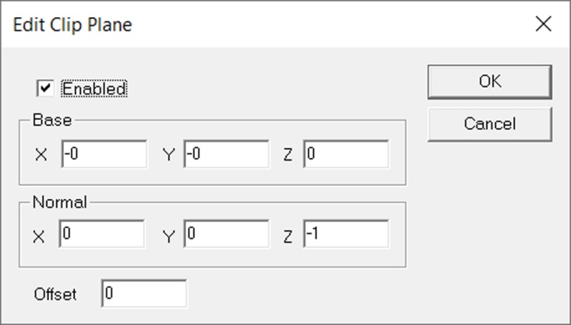

Fig. 1.7 Edit Clip Planedialog

##### Layers

Option Layers is used to enable or disable drawing of layers, Fig 1.7. Each model can have several layers to enable the users to choose which part of the model will be shown. When this option is selected, the dialog for editing layer options appears. Choose a layer from the list and set its visibility. Additionally, for 2D models using the Contour/Trajectory group box, you can change the visibility of contours which represents the borders of the model.

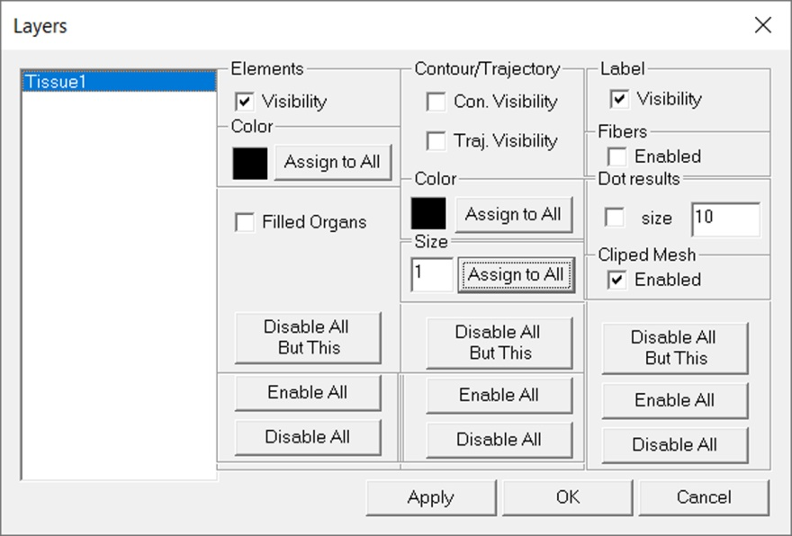

Fig. 1.8 Dialog Layers

##### Options

View Options dialog should be used to specify details about drawing of various view elements, Fig 1.9. In the list on the left, you can choose to draw the elements and enable or disable their visibility, and visibility of their labels. You can also show or hide nodes, elements, workplane, and coordinate axes for the model. The drawing color of each element and the color of the background can be specified as well. Button Font is used to set a font for a text in the workspace.

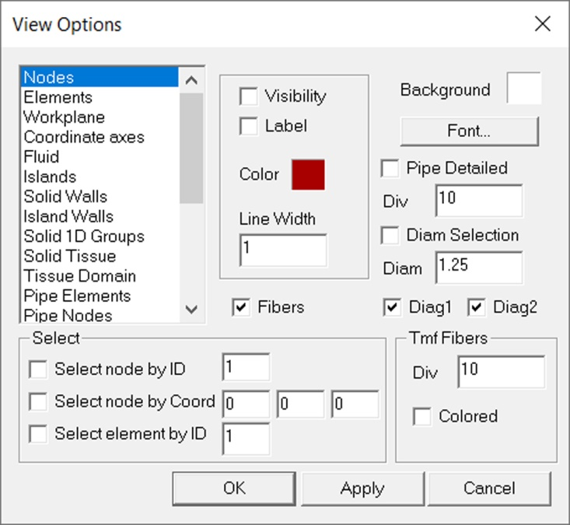

Fig. 1.9 View Options dialog

Once the view parameters are specified, the Apply button should be used to apply changes without leaving the dialog, or the OK button to apply specified parameters and close the dialog. The Cancel button closes the dialog and ignores all changes after the last Apply.

#### Calculation

Submenu Calculation provides options to generate the model according to last modified parameters, FE calculation of generated model, and specification of time steps for calculation, Fig.1.10.

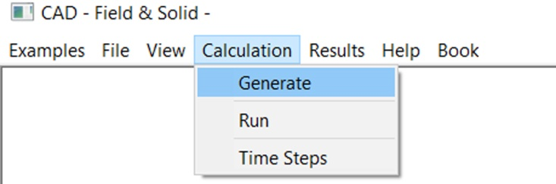

Fig. 1.10 Submenu Calculation

The Generate button is used to generate a model for the current module example according to parameters specified in the corresponding menu bar. Once the parameters are set, clicking on this button produces a preview of the model.

The Calculate button is used to run a calculation for the current model. Click on this button to provide generation of the finite element model according to parameters specified in the menu bar, and run a calculation using the corresponding PAK finite element software. When a calculation is finished, the results automatically appear in the Workspace.

The Time Steps button is used to specify time steps and time units for calculation in PAK-T finite element software, Fig. 1.11. When this option is selected, the dialog for editing time steps appears. In the group named Time Period, the Steps and Step Duration for FE calculation can be specified. LST printout can print file that contains results after the calculation is finished. NPRINT is used to set the step for printout (for example, every first or fifth step during calculation), and MAXIT is a maximal number of iterations during one time period of calculation. A tolerance for the convergence process must be specified. A restart of the calculation process can be selected by enabling the Restart group (a period or step to start calculation again can be selected).

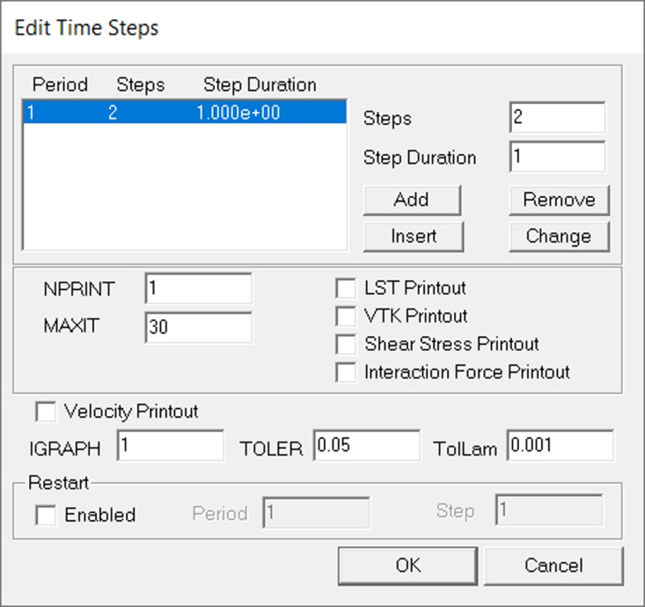

Fig. 1.11 Time Steps dialog

Note that the buttons Generate, Calculate and Time Steps are also available in the Common menu bar for the user's convenience.

#### Results

Submenu Results is used for selecting the results display options, Fig. 1.12a. This submenu is shown on the right-hand side of the Common Menu Bar for user convenience.

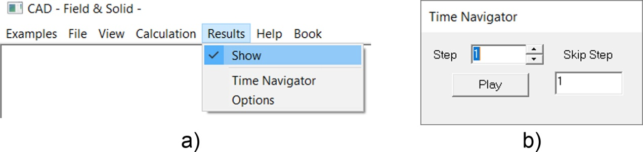

Fig. 1.12 a) Submenu Results; b) Time Navigator dialog.

Show checkbox is used to toggle between *Finite element model view* (pre- processing) and *Result view* (post-processing). Check or uncheck of this box is used for display of the results or the original model.

Time Navigator edit box is used to specify the time step for which the results will be shown, Fig. 1.12b. The use of arrows on the right side provides an increase or decrease of the step number.

The Options dialog is used to show a dialog with options for displaying results. Description of the Result options dialog is further given in section Result options.

##### Result options

The Result options dialog is used to define which results will be shown and how they will be displayed. Various types of diagrams can be chosen depending on the variable to be shown. Some types of diagrams can be combined to show two or more variables on the same drawing.

The Result options dialog is organized in four tabs: Contour plot, Vectors, Deformed, and Misc, Fig. 1.13.

Contour plot

The Contour plot tab is used to enable or disable the contour plot diagram and to set its parameters. In the contour plot diagram, values of the selected variable are displayed using different colors. The value of each color is shown in the palette in the upper right corner of the drawing.

The Enabled checkbox is used to enable or disable the contour plot diagram.

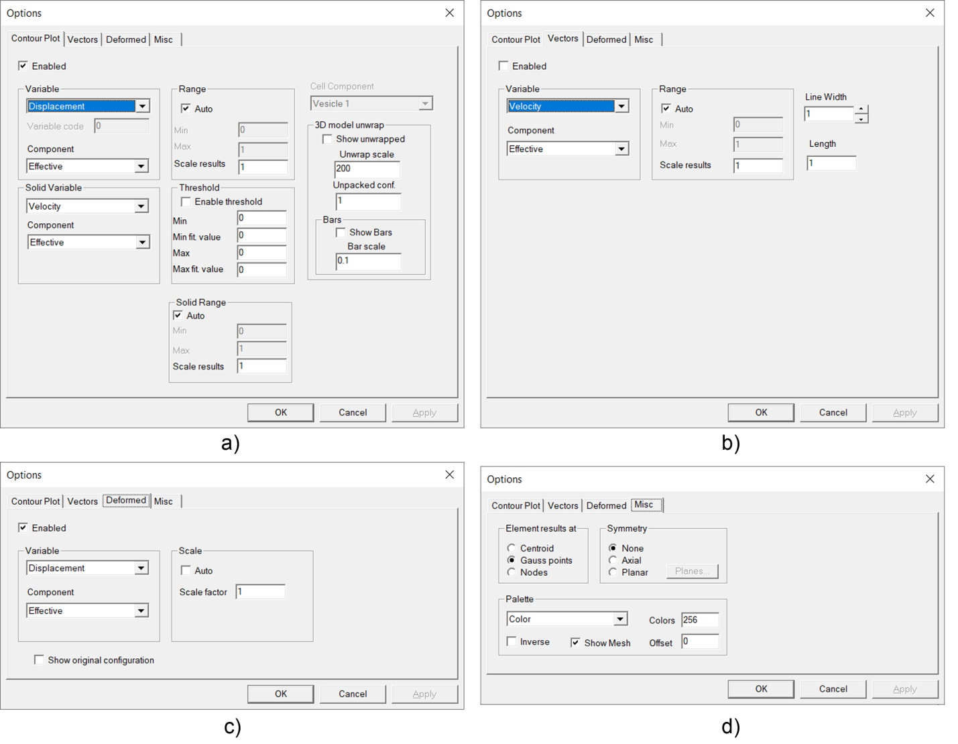

Fig. 1.13 Results Option dialog, with tabs, a) Contour plot; b) Vectors; c) Deformed; d) Misc.

Variable dropdown list is used to select a variable to be displayed using a contour plot diagram. The variables are displacement, velocity, force, stress, shear stress, strain, el. potential, concentration, pressure, flux, unit flux, diffusion coefficient, and a custom variable.

Range group is used to specify a minimum and maximum value displayed in the plot. The minimum value is shown by color at the bottom of the palette, while the maximum value is displayed by color at the top of the palette. When Auto is checked, the program automatically determines the minimum and maximum values of the selected variable.

Misc

Misc tab is used to set miscellaneous for result display.

Element results at options define where the element results are stored during the solution process.

Palette group is used to specify palette type and number of colors in the palette used in the contour plot. A selection between color and gray scale is available, while the number of colors must be between 2 and 256. The Inverse check box is used to make the reverse colors order.

Show mesh checkbox is used to enable or disable drawing of finite elements in the contour plot.

Symmetry group is used to display results symmetrically. Either Axial or Plane symmetry can be selected to get results displayed axisymmetrically or in one of four coordinate quadrants.

#### Help

In the Help submenu are given basic information About CAD software, Fig. 1.14.

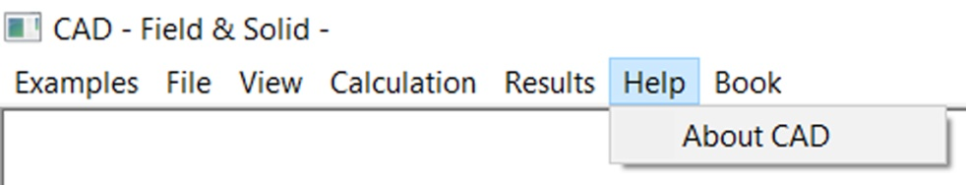

Fig. 1.14 Submenu *Help*

### **1.3. Workspace**

Workspace is the area where the model is drawn and where the results of a FE simulation will be loaded and displayed, Fig. 1.15. Workspace works in two modes: *Finite element model view* and *Result view*. The *Finite element model view* is used to see the original configuration of the model including its geometry and finite element mesh. The *Result view* is used to display calculation results such as concentration, mass flux, displacements, velocities, etc.

Regardless of the active mode, you can manipulate the view using Zoom, Pan, Viewpoint, and other view options.

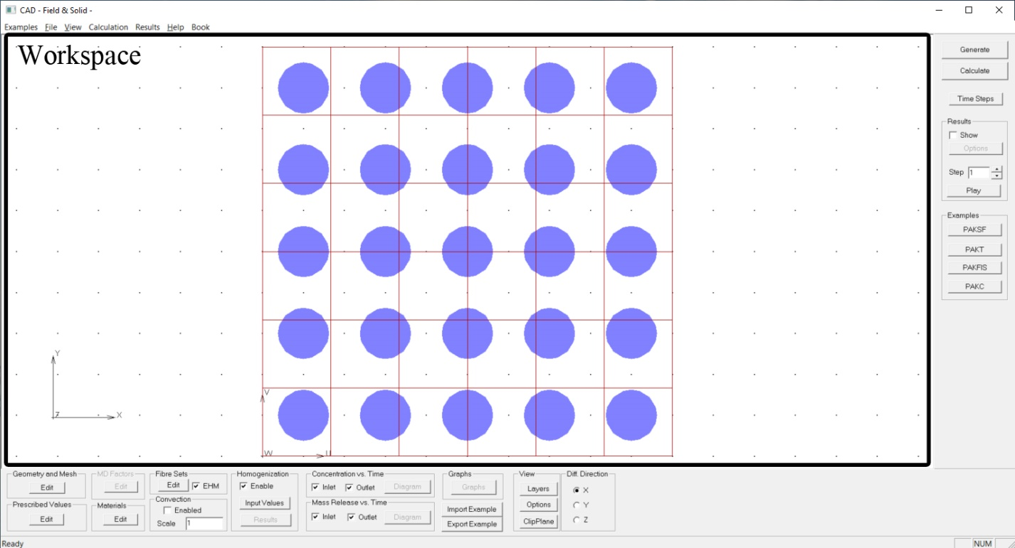

Fig. 1.15 Workspace of the CAD – Field & Solid software

### 1.4 Common menu bar

The Common menu bar is the menu placed on the right side of the software window, containing common options for the membrane model. All these options are described in Section 1.2 (Main menu).

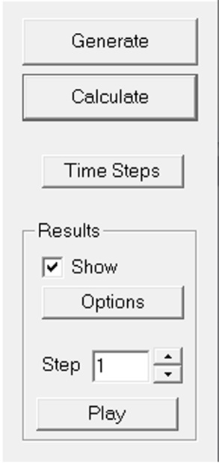

Fig. 8.2.16 Common menu bar

Generate button is used to generate the current model.

Calculate button is used to run the calculation for the current model.

Show checkbox is used to toggle between *Finite element model view* and *Result view*.

Options button is used to show a dialog with options for displaying results.

Step edit box is used to specify the time step (load step) for which the results will be shown.

Play button is used for automatic simulation of the process.

## 2 PAKSF module

TO DO

Figure 2.1 PAKSF module within CAD

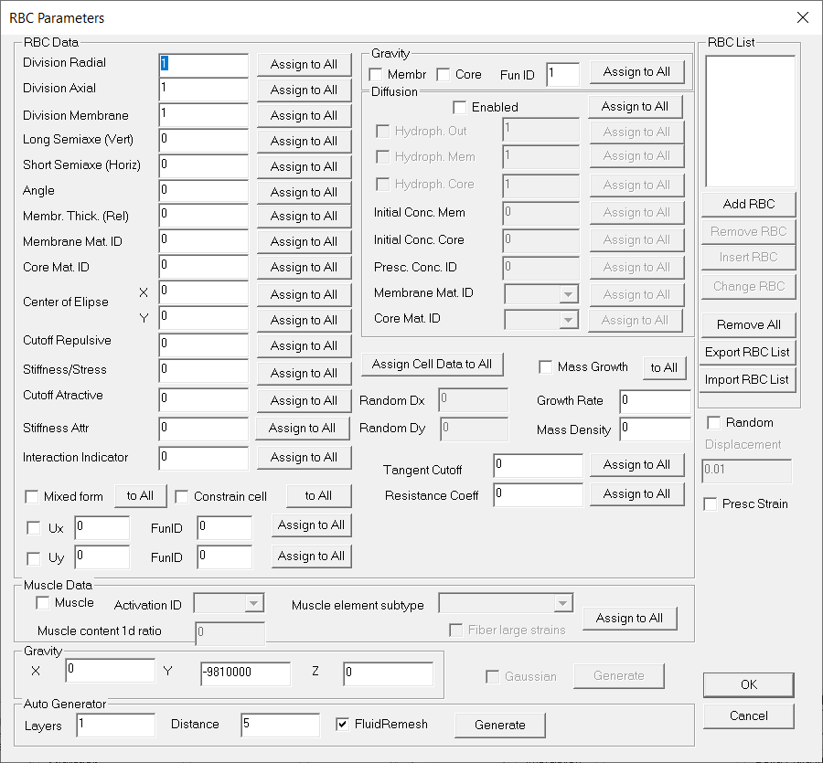

Figure 2.2 RBC Parameters

RBC complex cells

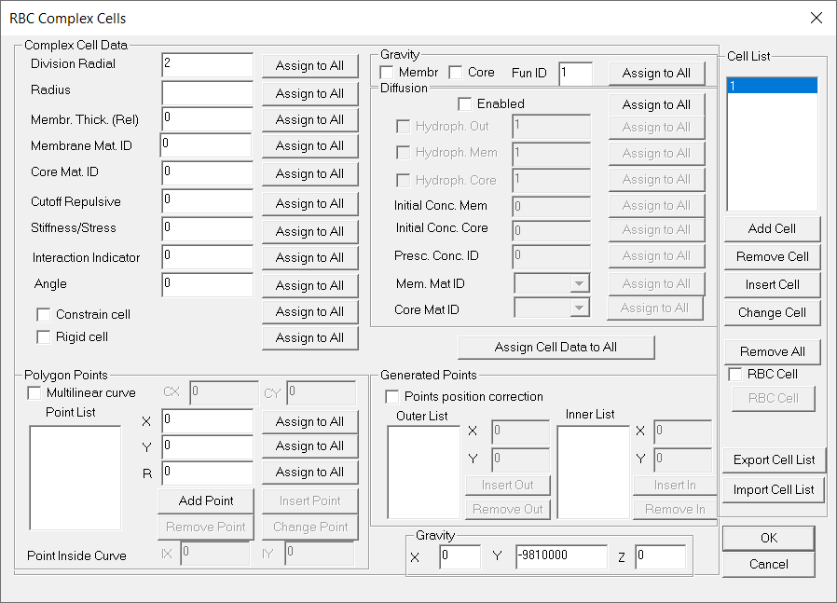

Figure 2.3 RBC Complex cells

Fluid Parameters

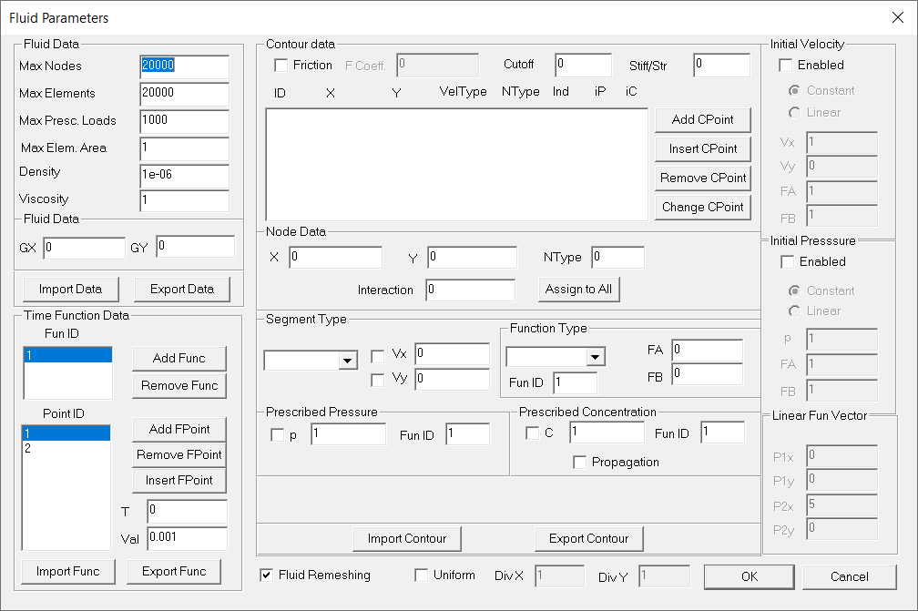

Figure 2.4 Fluid Parameters 2D

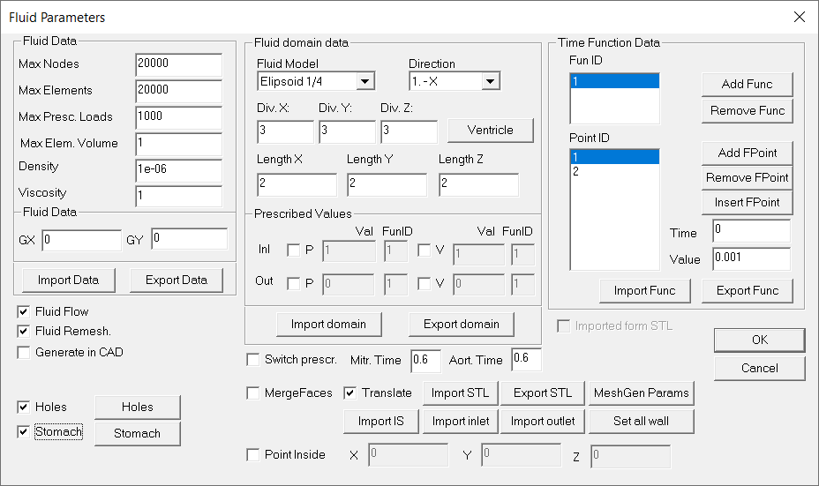

Figure 2.5 Fluid Parameters 3D

Diffusion/Heat Parameters

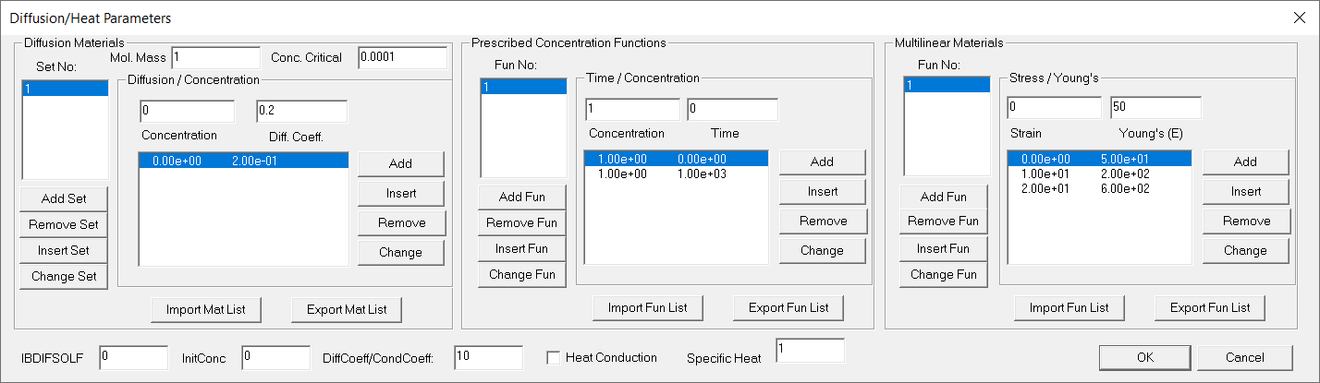

Figure 2.6 Diffusion / Heat Parameters

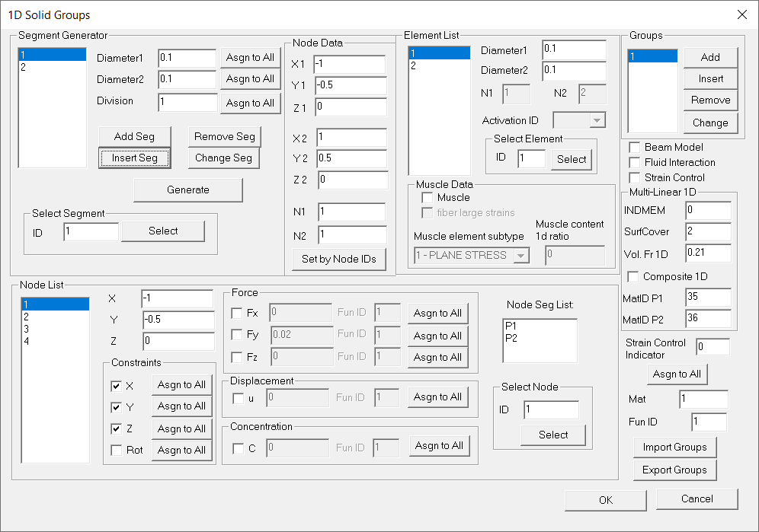

Figure 2.7 1D Solid Groups

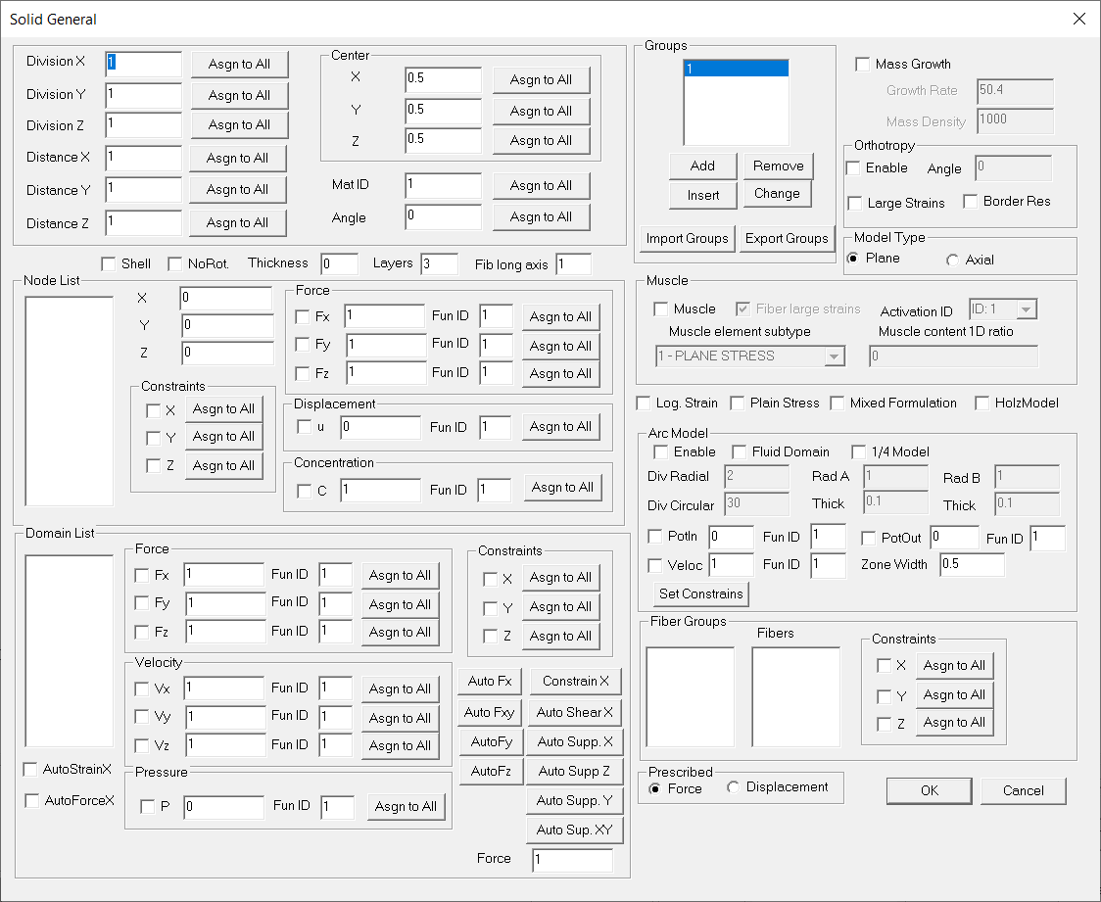

Figure 2.8 Solid General – Used for both 2D and 3D problems

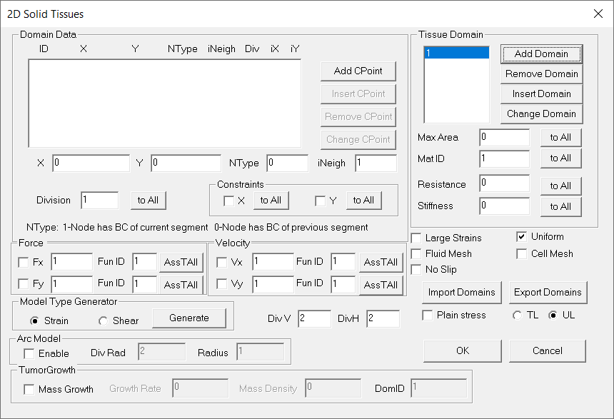

Figure 2.9 2D Solid Tissue

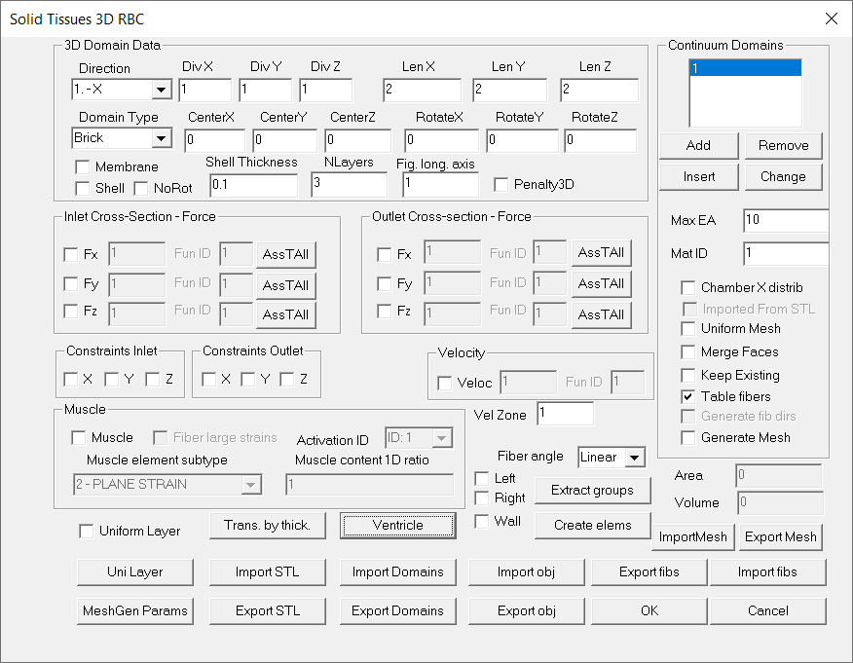

Figure 2.10 - 3D Solid Tissue

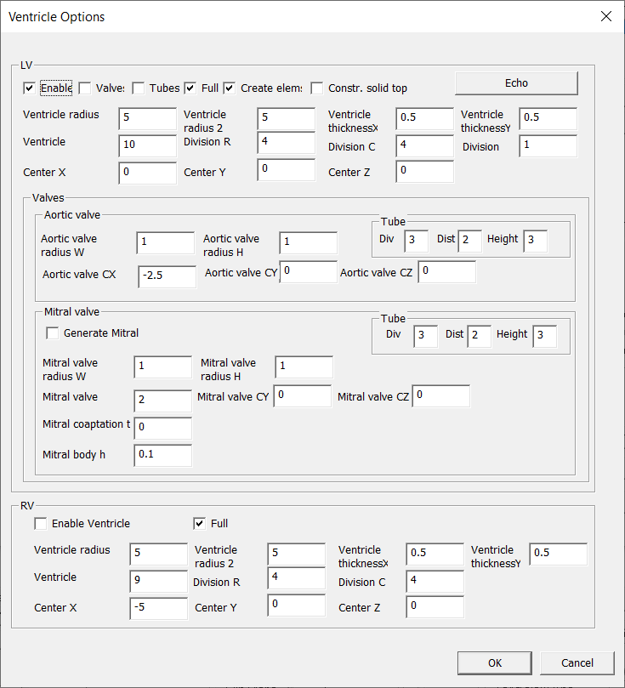

Figure 2.11 Ventricle Options

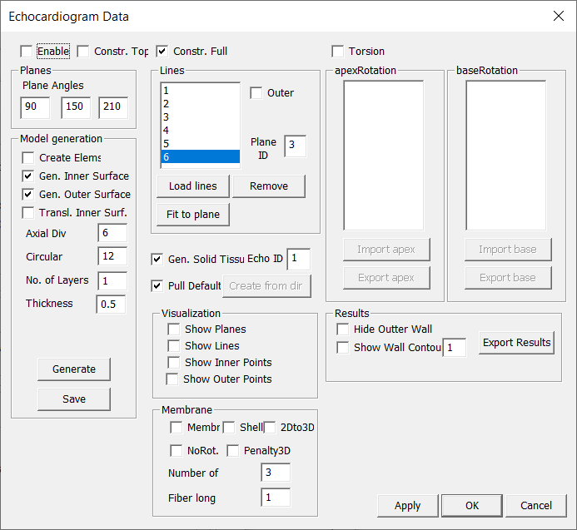

Figure 2.12 Echocardiogram Data

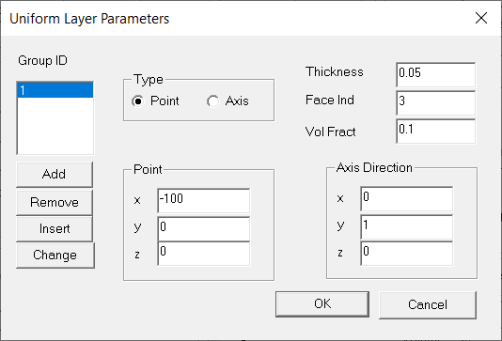

Figure 2.13 Uniform Layer Parameters

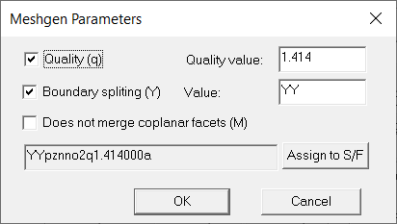

Figure 2.14 Meshgen Parameters

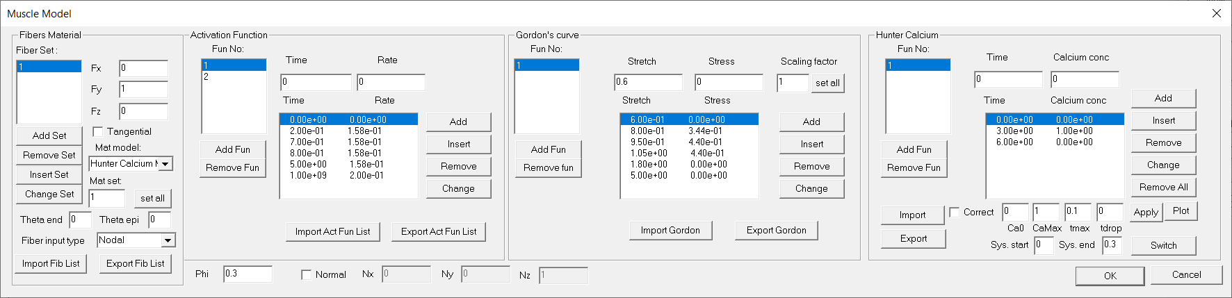

Figure 2.15 Muscle Model

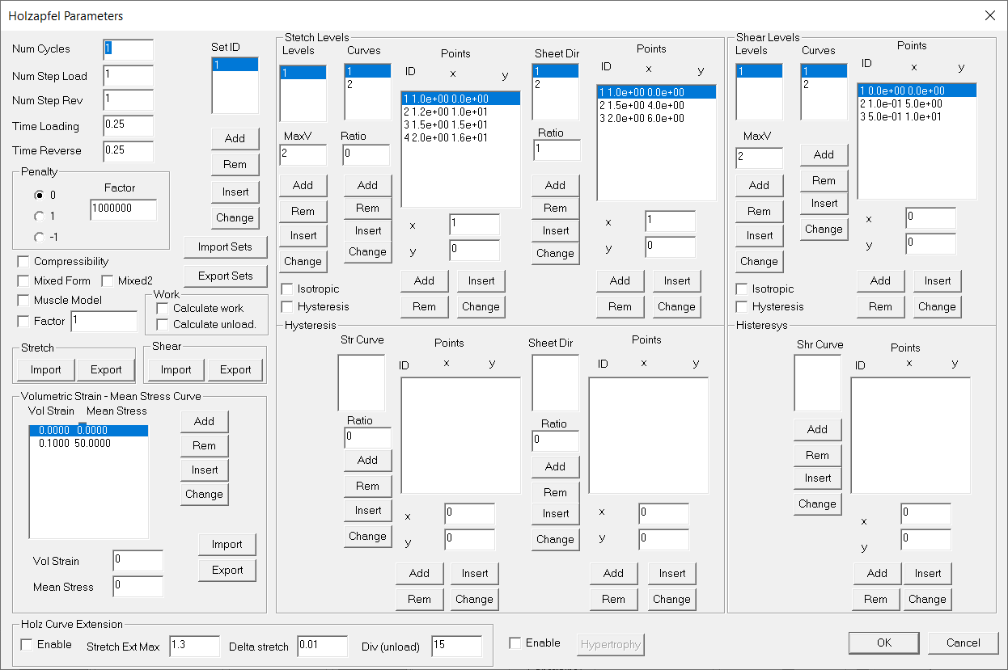

Figure 2.16 Holzapfel Parameters

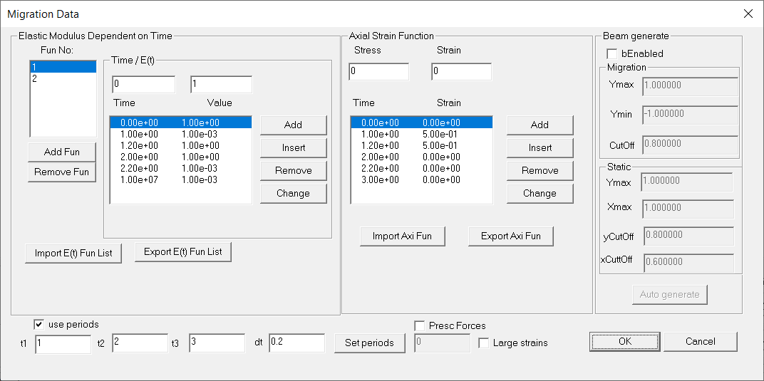

Figure 2.17 Migration Data dialog

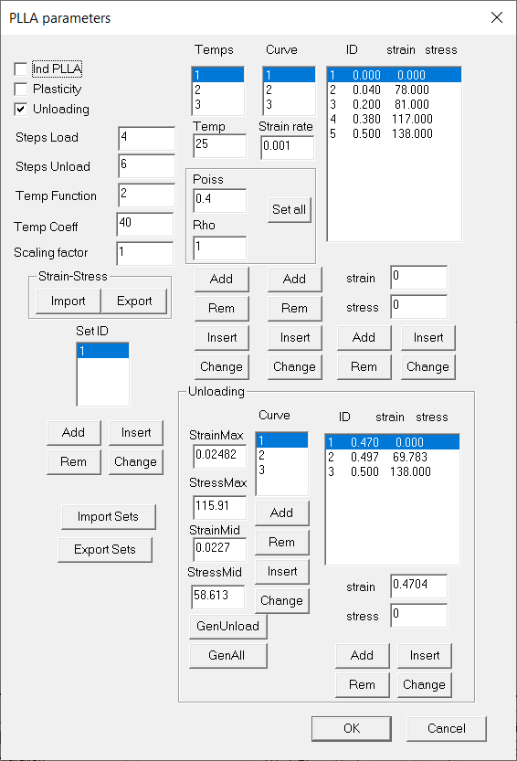

Figure 2.18 PLLA Parameters

Dialog Solid Materials

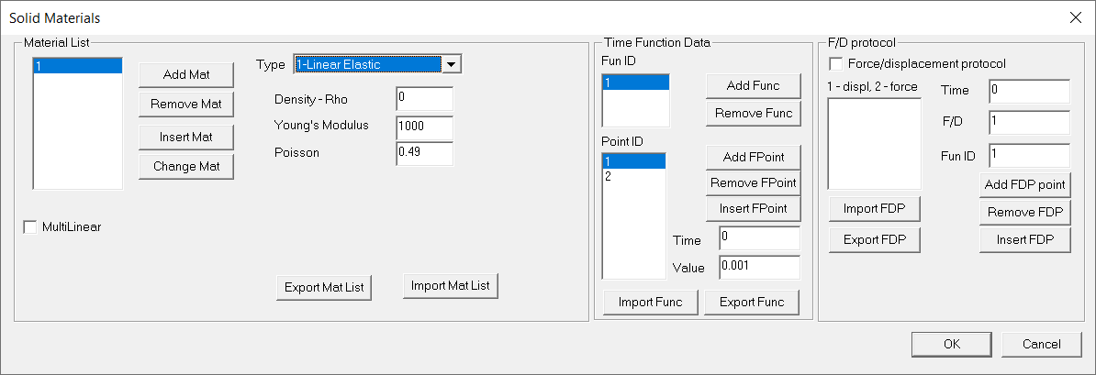

Figure 2.19 Solid Materials

List of material models that can be used in CAD is:

1. linear elastic
2. linear viscoelastic
3. fluid
4. creep (both elastic or viscoelastic)
5. linear elastic- mixed formulation
6. linear viscoelastic - mixed formulation
7. elastic creep - mixed formulation
8. viscoelastic creep - mixed formulation
9. linear elastic orthotropic
10. linear visco-elastic orthotropic
11. linear elastic- beam
12. linear visco elastic - beam
13. Hill's model
14. Maxwell viscoelastic model for cells
15. Hunter calcium model
16. Huxley Surrogate
17. Holzapfel hyperelastic model
18. PLLA Model
19. PLLA Experimental Curves Model
20. Mc Evoy Holzapfel model
21. Analytical Lafortune Aris Vazquez Houzeaux
22. Ogden Hyperelastic Material
23. Mooney Rivlin Hyperelastic Material
24. Multilinear elastic model for 1D elements
25. Biaxial Membrane model
26. Surfactant hysteretic model
27. Uniaxial Sasaki-Hoppin Hysteretic model

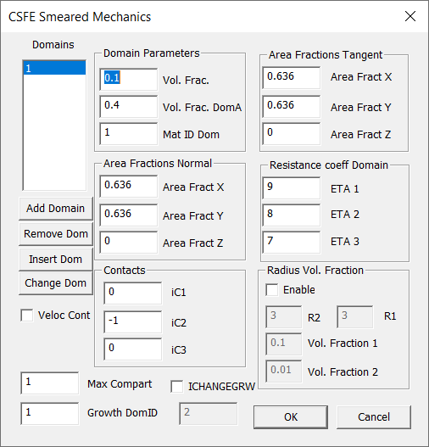

Figure 2.20 CSFE Smeared Mechanics

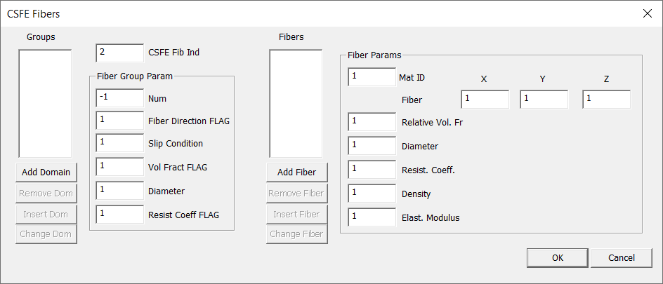

Figure 2.21 CSFE Fibers

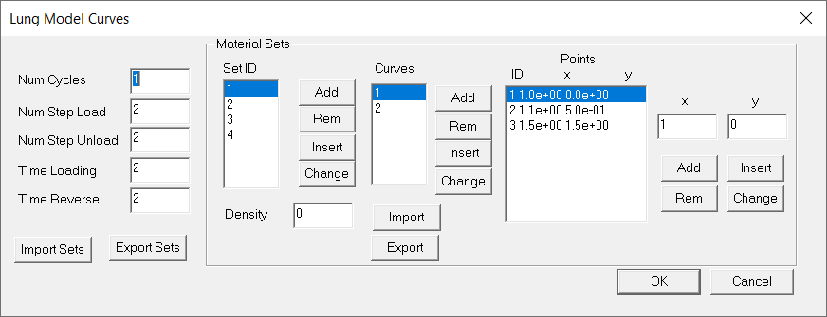

Figure 2.22 Lung Model Curves

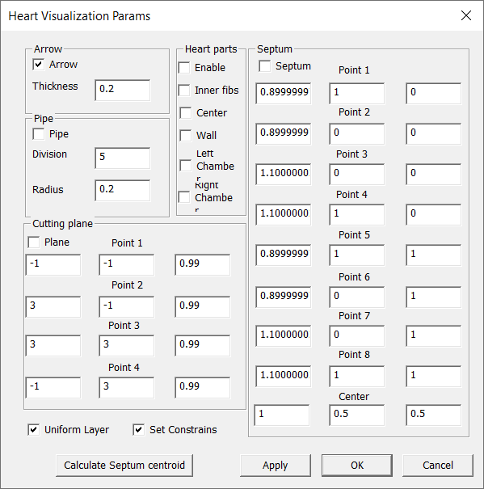

Figure 2.23 Heart Visualization Parameters

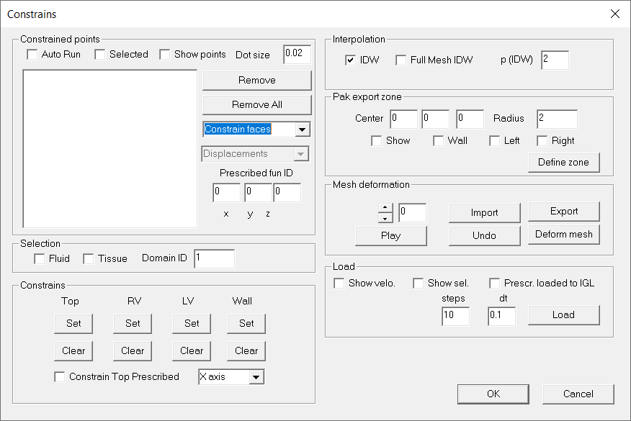

Figure 2.24 Constraints dialog

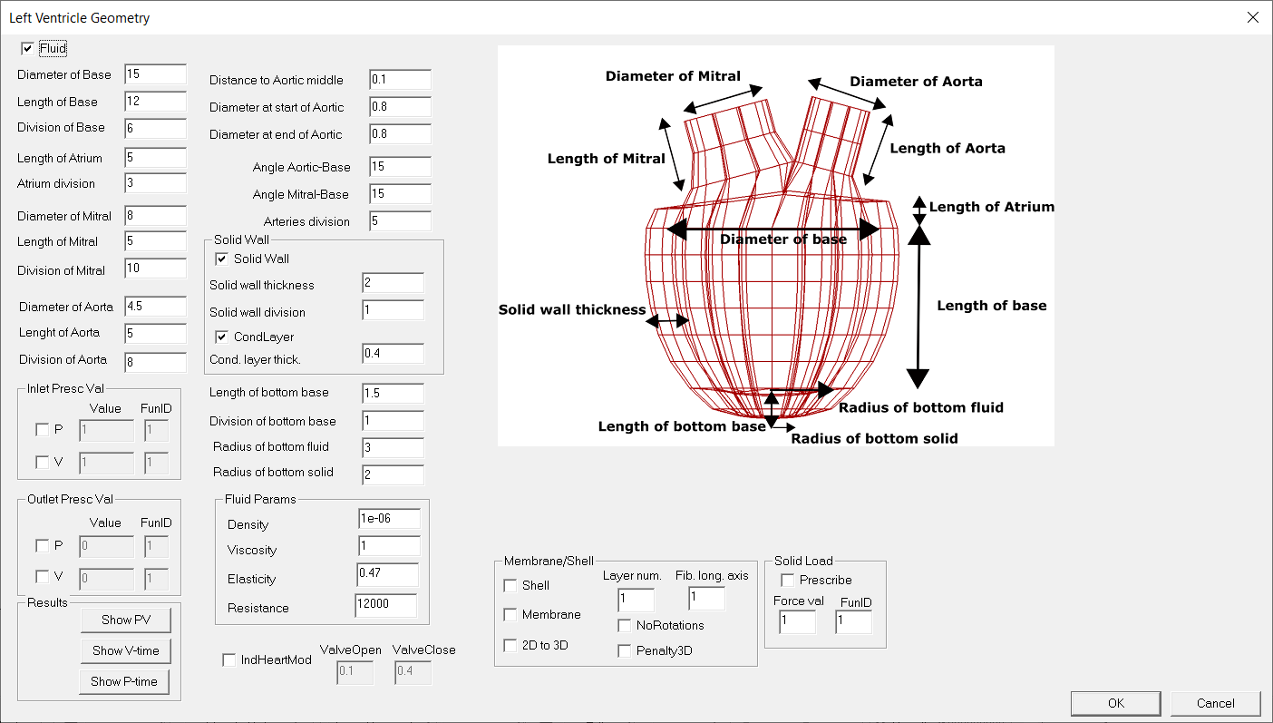

Figure 2.25 LV Ventricle Geometry

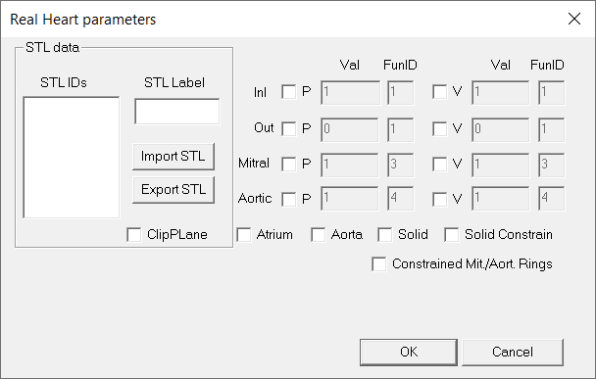

Figure 2.26 Real Heart Parameters

## 3 PAKT module

Sdsdsd

## 4 PAKFIS module

Sdsd

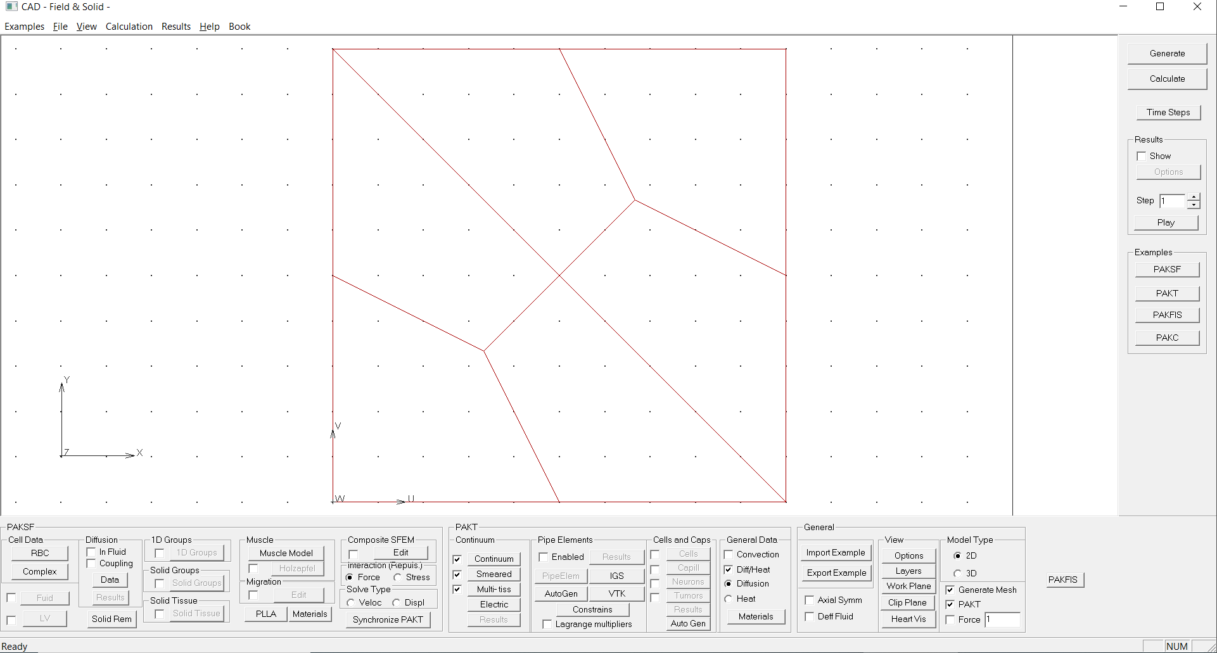

Figure

## 5 PAKSF2D module

Sdsd

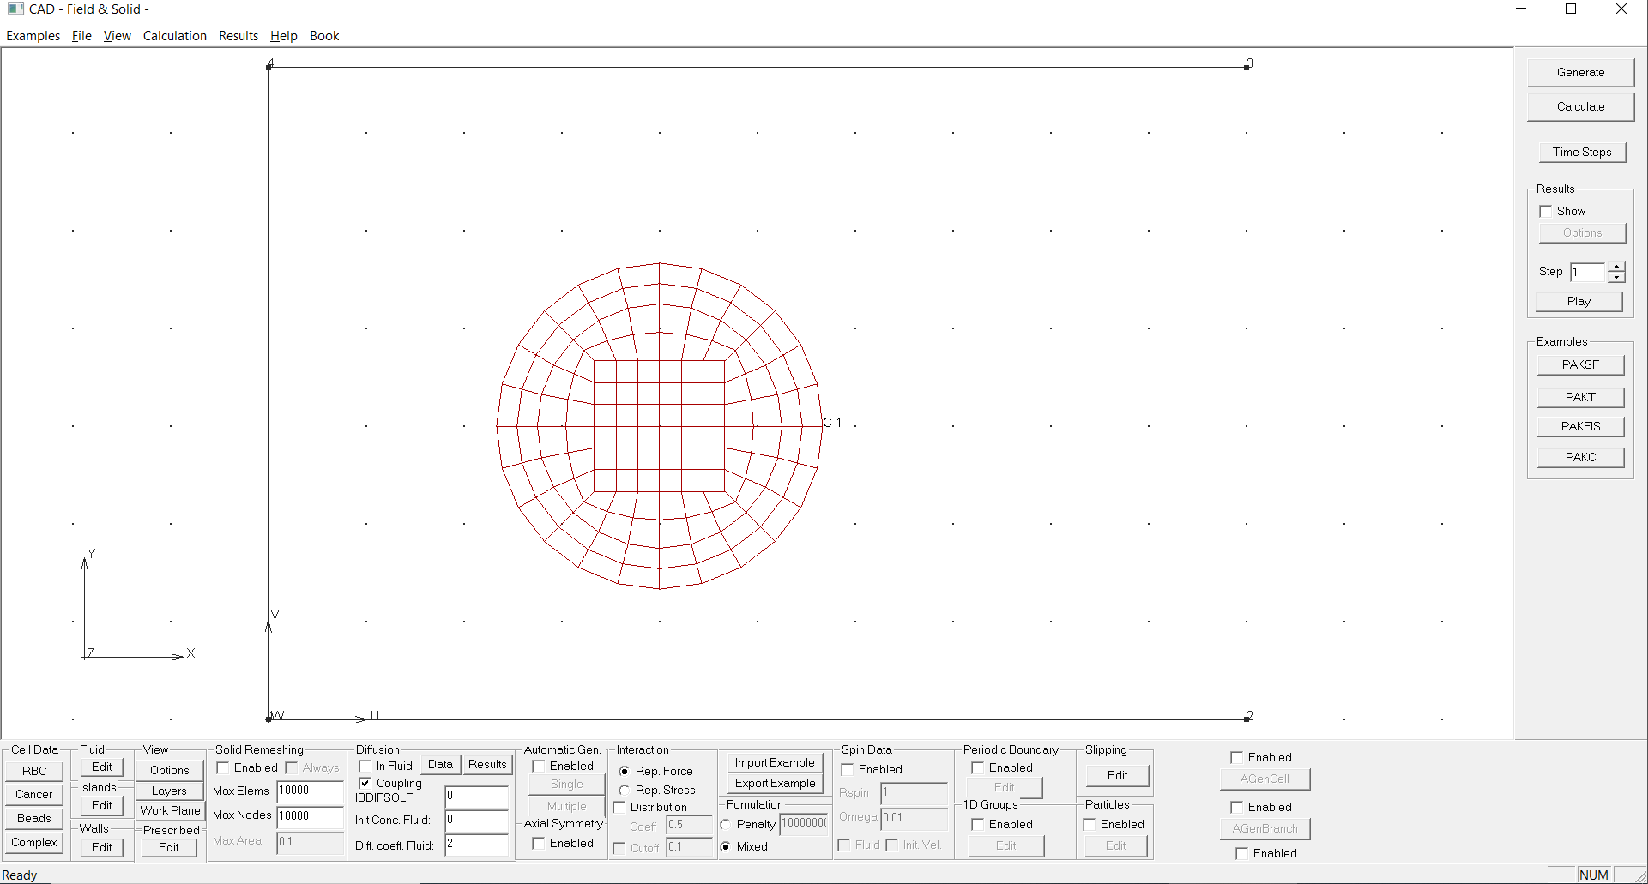

## 6 PAKSF3D module

Sdsd

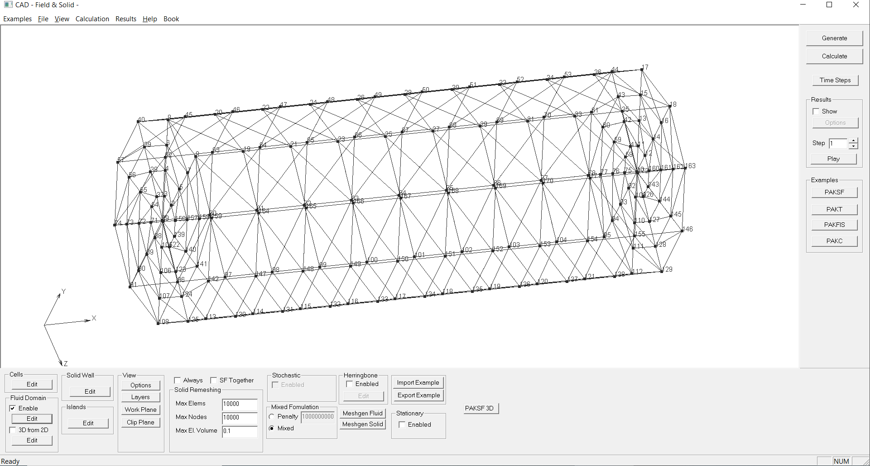

Figure

## 7 Composite2D module

Sdsd

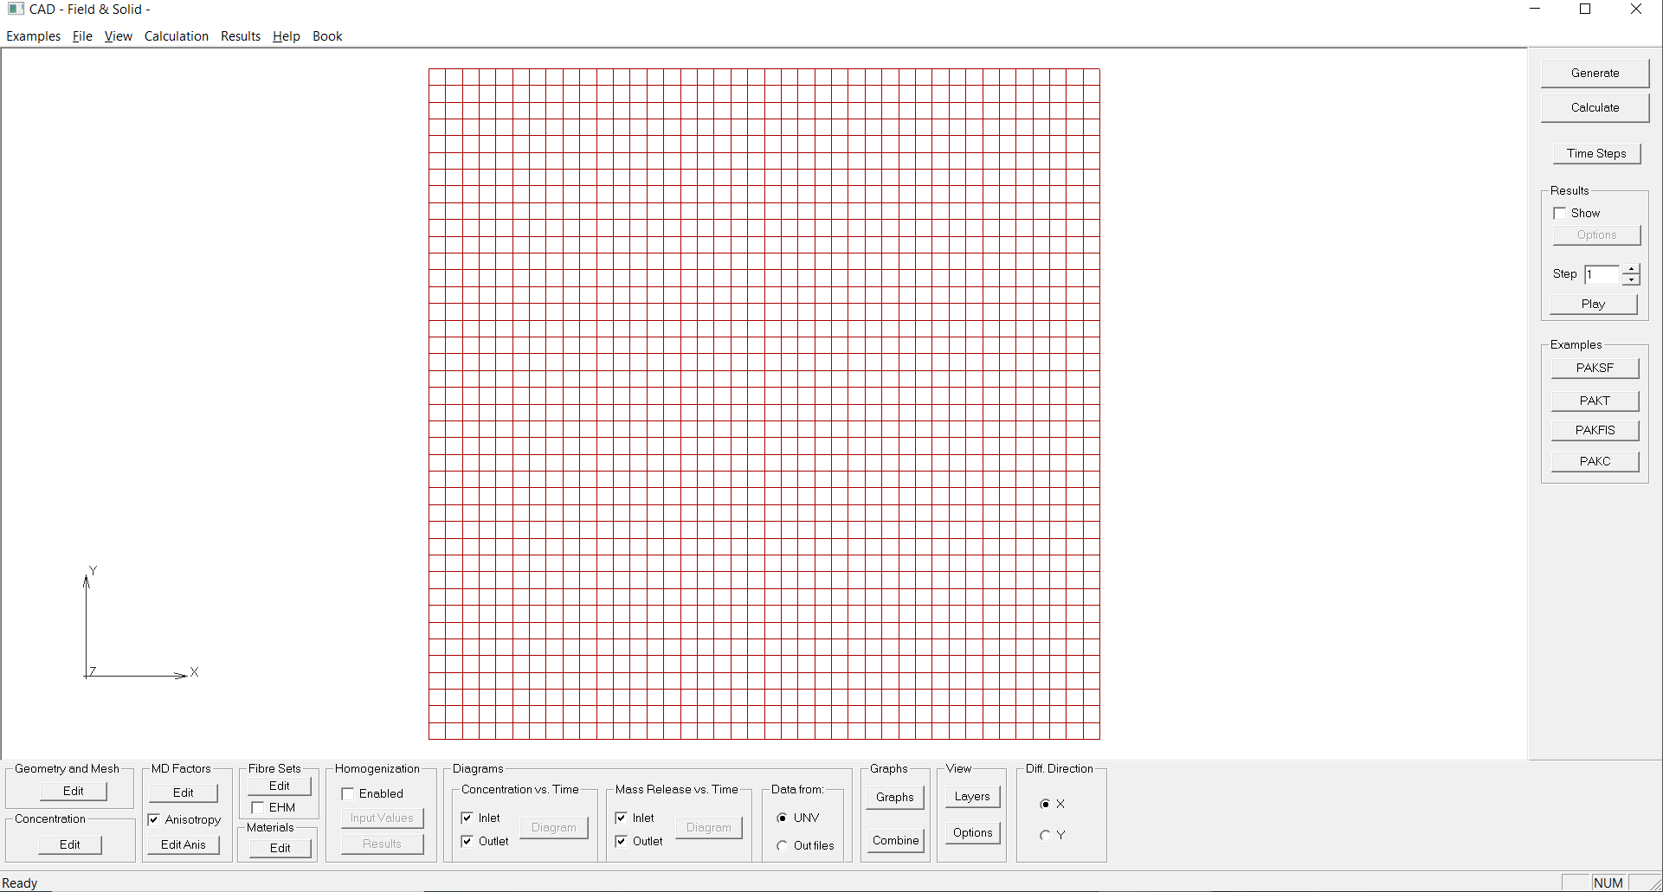

Figure

## 8 Composite3D module

Sdsd

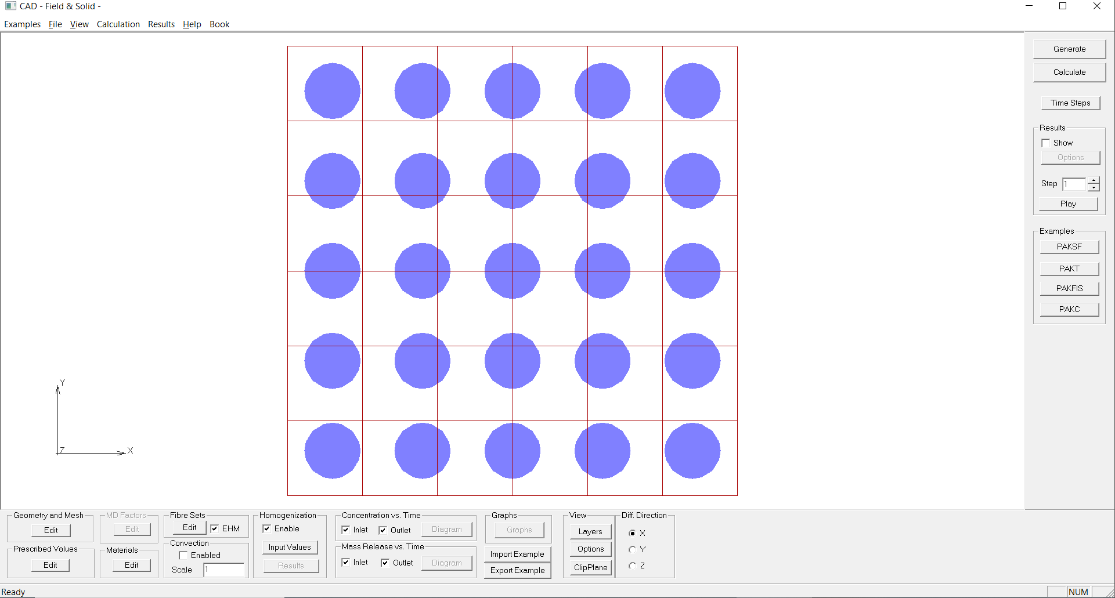

Figure

## 9 Partitioning module

Sdsd

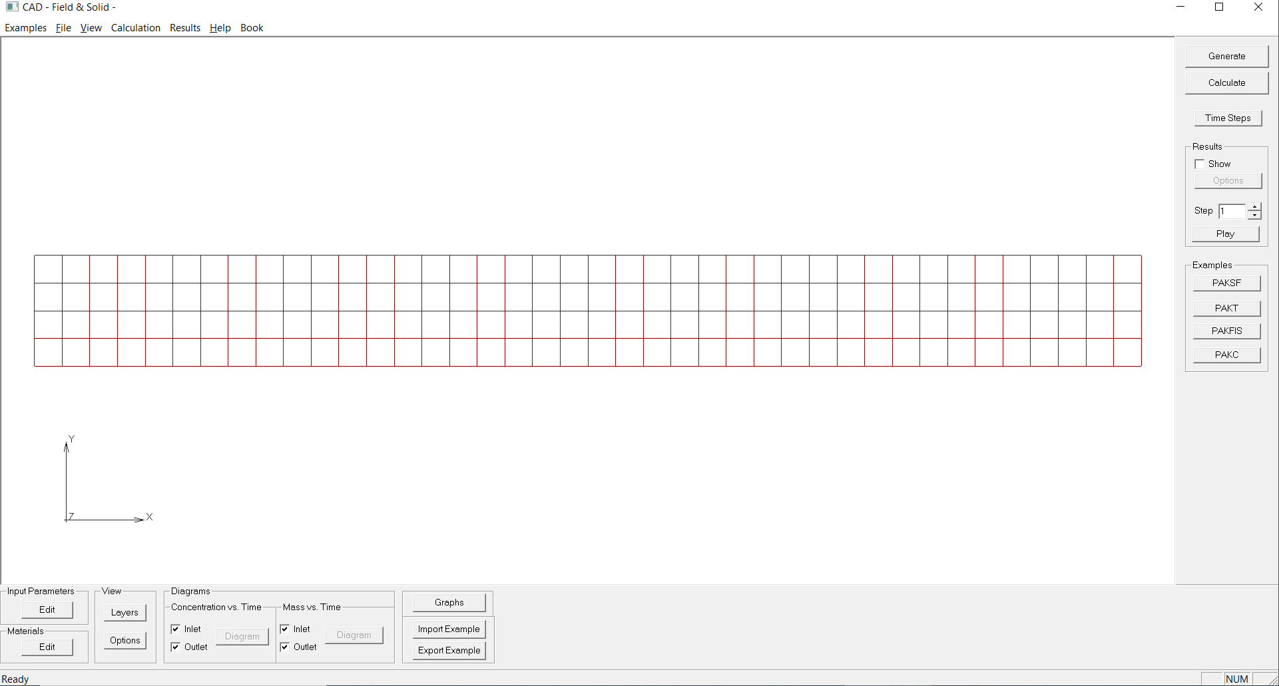

Figure

## 10 PAKC module

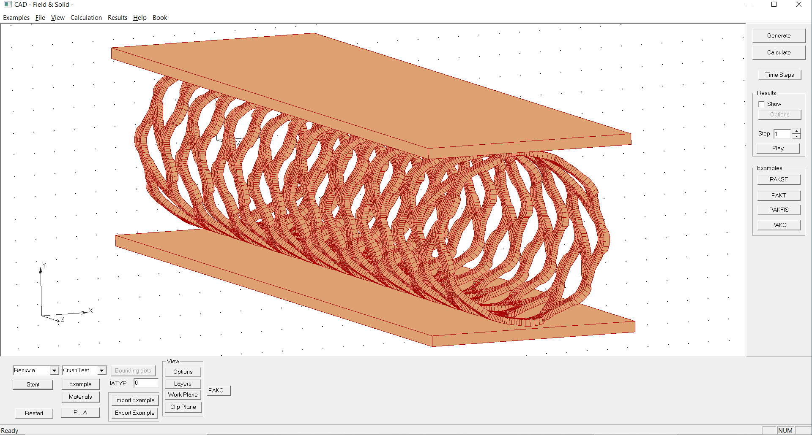

Figure 10.1 PAKC module for stent optimization and validation

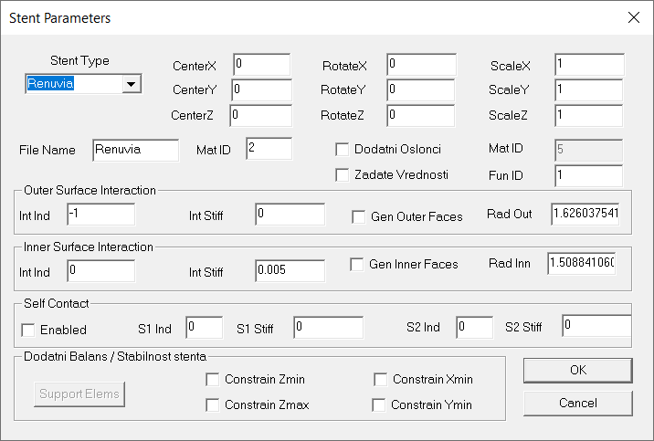

Figure 10.2 Stent parameters

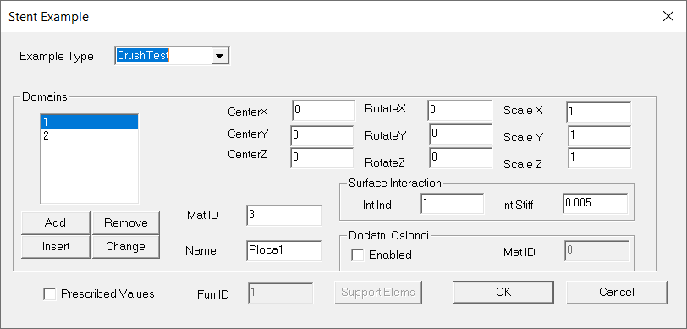

Figure 10.3 Stent Example

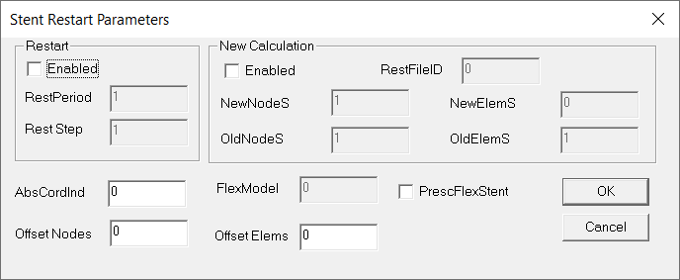

Figure 10.4 Stent Restart Parameters

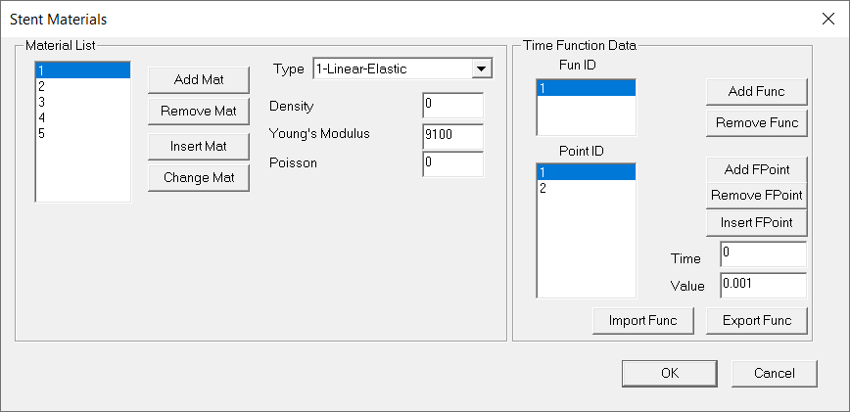

Figure 10.5 Stent Materials

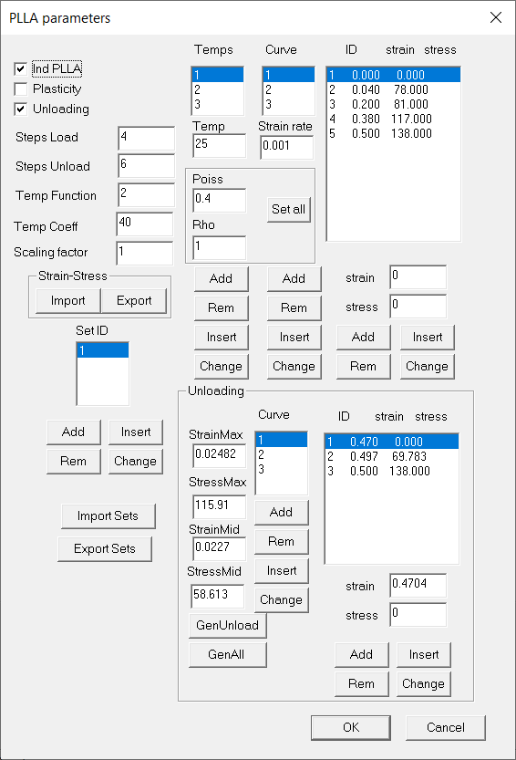

Figure 10.6 PLLA parameters

## 11 Nanofibers module

Sdsd

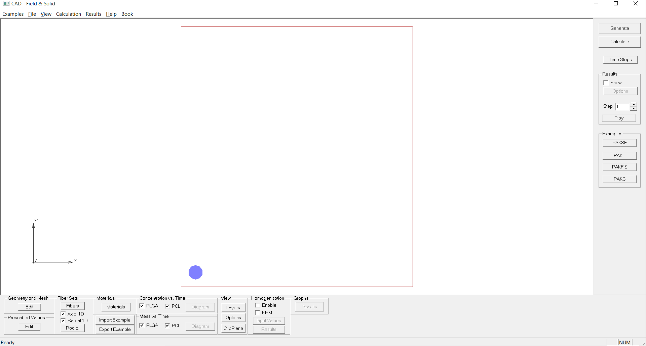

.Figure

## 12 Nanofibers smeared module

Sdsd

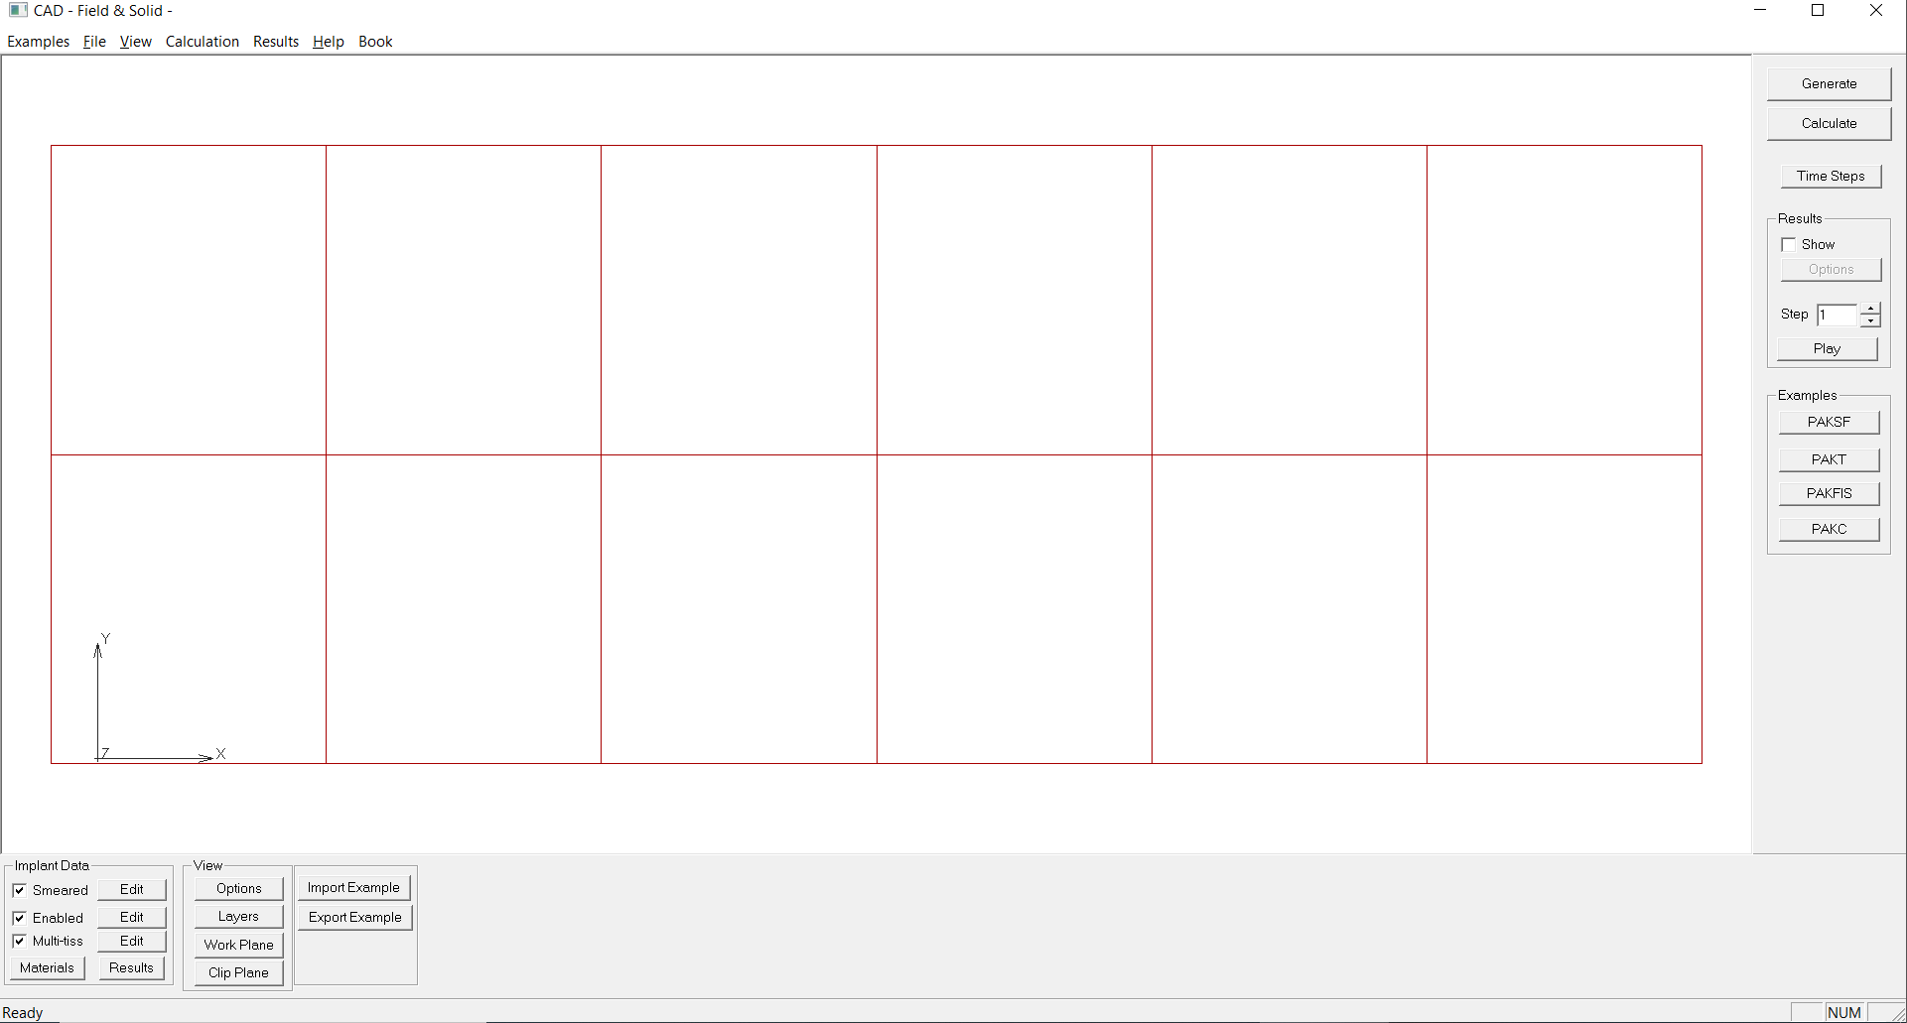

Figure

## 13 Cell Tissue module

Sdsd

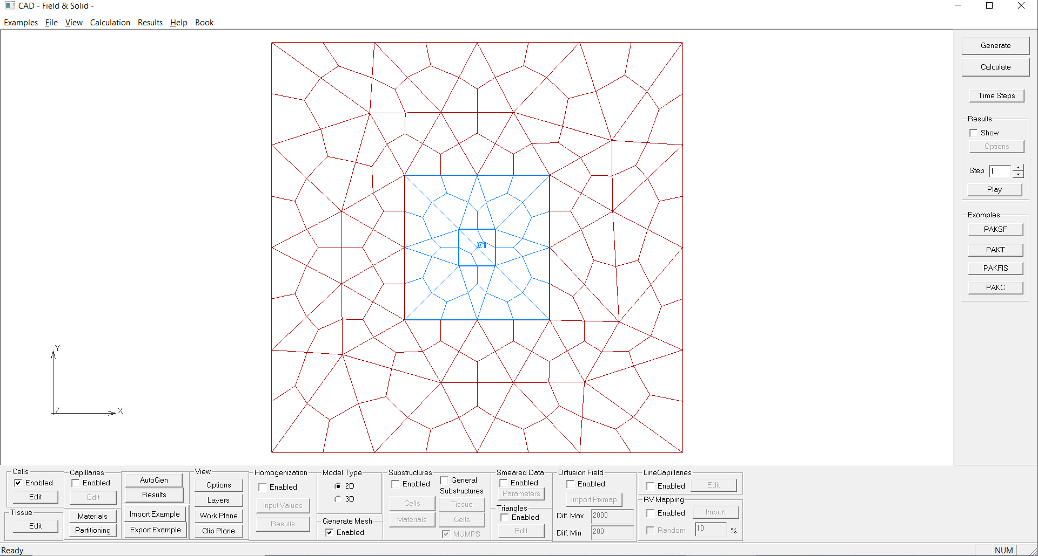

Figure

## 14 Param Space module

Sdsd

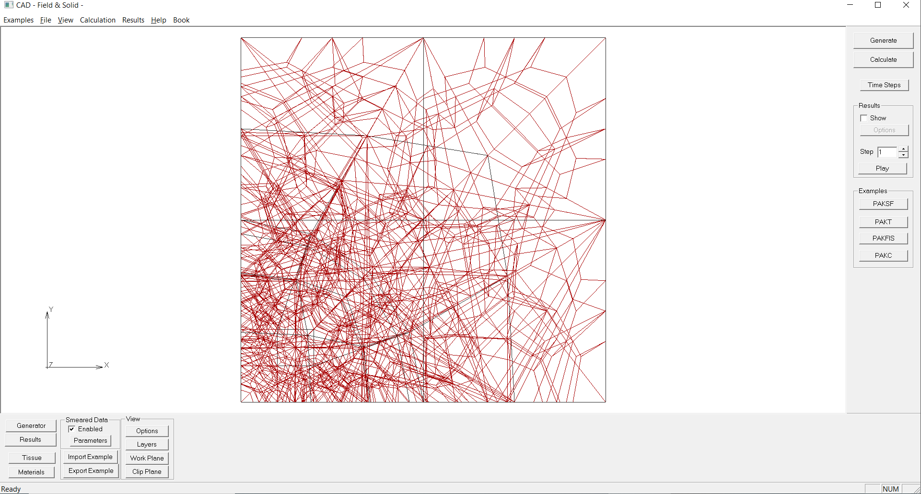

Figure

## 15 Metastatic Tumor module

Sdsd

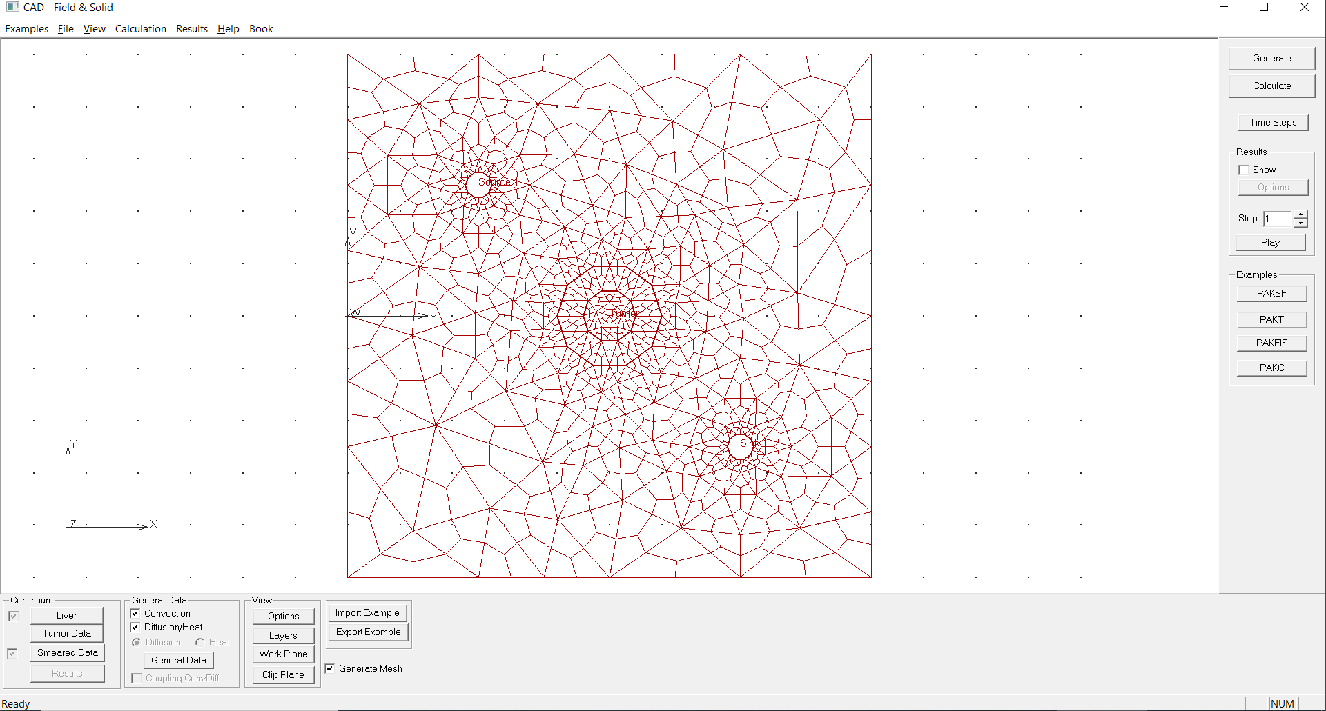

Figure

## References

…